**SEPTEMBER EXAM PERIOD 2023**

SEPTEMBER 4 (Monday), 08:30, Amphitheater SILOS

* 100 questions (min 51 correct answers to pass exam)
* duration of exam 120 min
* exam results – Wednesday, September 6, 14:00
* if you choose wrong answer, you can mark another one but put your signature/initials beside correct answer; corrected answer without initials will not be accepted!; you can correct a maximum of 7 questions: 3-bacteriology, 2-parasitology-mycology & 2-virology
* bringing indexes & fully completed white application form to the exam is compulsory !
* arrive on time on exam (amphitheater door should be locked 5 min after 08:30)

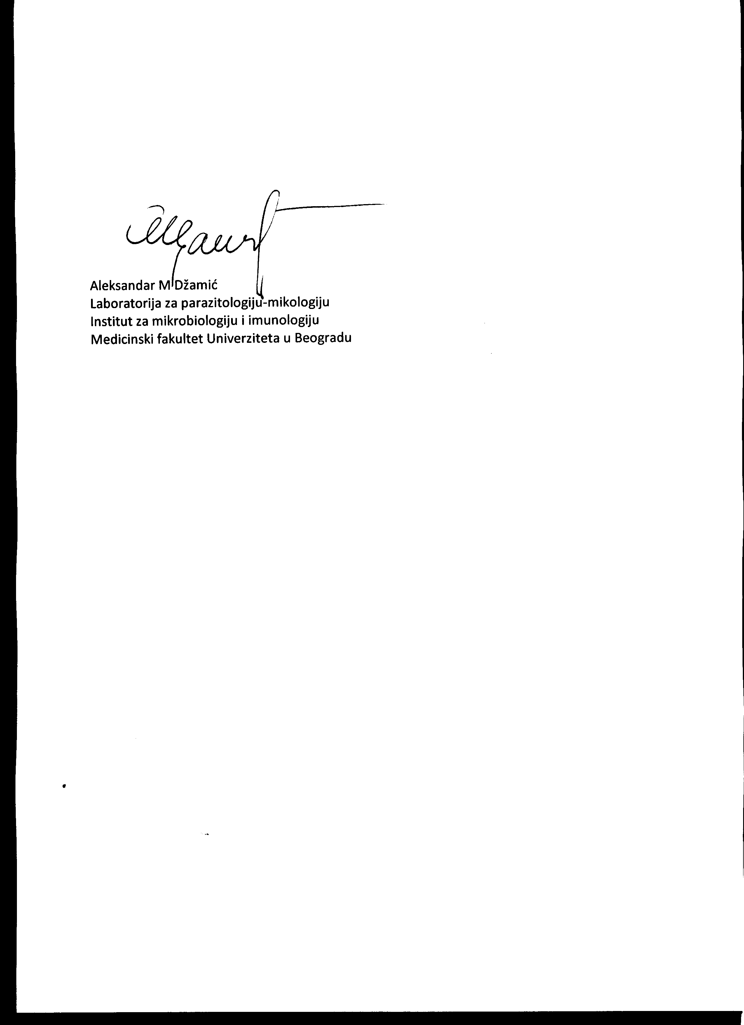

Prof AM Džamić August 24, 2023, Belgrade